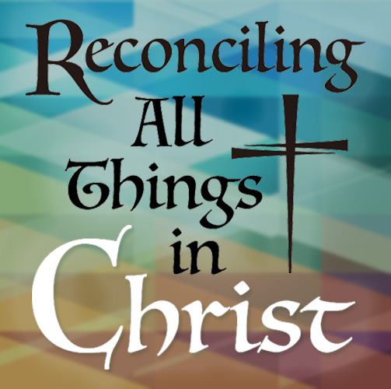
Information about Resolutions
2019 Convention, The Episcopal Church in East Tennessee
Resolutions due at Diocesan House by Jan. 6, 2019

How to Write a Resolution

Sec. 10. Any Delegate, Vestry, Area Commission, the Bishop and Council, the Chancellor, the Chair of the Committee on Constitution and Canons, and the Registrar of the diocese may submit resolutions for consideration by the Convention by delivering them to the Secretary of the Convention at least thirty days prior to the date set for the Convention. They may also introduce resolutions at the Convention in accordance with the Rules of Order.

THE WHEREAS CLAUSE
Reasons and justifications for resolutions should be included in an explanation following the resolution, so it is clear that a vote is being taken only on the substance of the resolution. A “whereas clause” should not be used.

DETAILS OF FORM
- The Title
- The Resolution
The word “Resolved” is capitalized and underlined, and it is followed by a comma and the word “That,” which is capitalized. Each resolving paragraph may end with a period or with a semicolon and the words “and be it further.” NOTE: “Therefore be it” and “and be it further” end a clause. They are not used at the beginning of a “Resolved” clause.
- The Explanation
Here should be clearly and succinctly set forth the reasons for the proposed action called for in the resolution, and the anticipated financial impact (if any) on the diocese or congregations.

HOW TO WRITE A RESOLUTION OF COURTESY OR APPRECIATION
Resolutions of Courtesy or Appreciation, which are written to be read aloud, may have “whereas clauses,” but they should not include an explanation following the resolution. The form is the same as for resolutions.

Please be sure to include your name, e-mail address and phone number (or that of your group’s representative) in your proposed resolution.

  - Proposed resolutions must be received at Diocesan House no later than Jan. 6, 2019 to be posted on our convention website and included in convention packet. Resolutions proposed after Jan. 6, will be made from the floor of convention. Bring 300 copies of the resolution for distribution to convention participants – given to the Secretary of the Convention before the start of business on Friday, Feb. 8.

SAMPLE RESOLUTION

THE EPISCOPAL CHURCH IN EAST TENNESSEE

2019 DIOCESAN CONVENTION

TITLE: Humor

PROPOSED BY: The Rev. I M. Fun, rector, Our Lady of Perpetual Laughter, Witville

REPRESENTATIVE’s CONTACT INFORMATION:
The Rev. I. M. Fun
20 Jocularity Lane, Witville, TN 00001
555-244-5653
rector@ourladyofperpetuallaughter.net

REPRESENTATIVE AT CONVENTION:
The Rev. I. M. Fun

DATE: (Of submittal)

RESOLVED, That this 35th Annual Convention of the Episcopal Church in East Tennessee endorses and commends a sense of humor to each of the Bishops, Priests, Deacons and Laypersons of the Diocese; and be it further

RESOLVED, That the Secretary of convention, without delay, transmit this resolution to the clergy of this Diocese not present at convention so that all areas of the Diocese will swiftly and strictly adopt a sense of humor without delay.

EXPLANATION OF RESOLUTION:

The Episcopal Church in East Tennessee has endorsed a variety of good qualities, but has never endorsed this quality, which we recognize as being good for our spiritual and physical well-being. We are mindful of our negligence.

For Office Use Only
Number
Date Received

Due at Diocesan House by Jan. 6, 2018
THE EPISCOPAL CHURCH IN EAST TENNESSEE
814 Episcopal School Way, Knoxville, TN 37932
Send to: mbolt@dioet.org

RESOLUTION
35th ANNUAL DIOCESAN CONVENTION
Feb. 8-9, 2019

Resolution title Proposed by Date

Resolution Writer Contact Information
Name Address Phone number E-mail address
Representative at the convention:

Resolved:

Explanation of Resolution:

